Administrator Guide

  - Configure user provisioning with Okta

This guide provides details about SmartSolve and Okta provisioning integration, including features, requirements and configurations.

Supported Features
Provisioning is only available for Internal Actors in SmartSolve. A user will not be available for provisioning if internal actor is migrated to Person.
Currently only downstream provisioning from Okta to SmartSolve is supported.
Following user account operations are supported. Syncing groups is not yet available.
- Create new Account
New users created from Okta will be provisioned in SmartSolve. User will be enabled to log in and default role name: ‘UNIVERSAL REQUIREMENT ROLE’ will be assigned.

- Update user's account details
Supported User attributes updated in Okta will be updated in SmartSolve.
- Activate a user account
Reactivating a user in Okta will enable log in for the user in SmartSolve.
Note: All roles previously assigned will be intact.
- Deactivate a user account
Deactivating a user in Okta will disable log in for the user in SmartSolve.

Prerequisites
Contact SmartSolve representative to enable the provisioning through Okta. Your SmartSolve contact will provide you with the Base URL and User account details required to authenticate and enable the integration.
Please add following attributes in the Okta User Profile if not available.
Display Name | Variable Name | Data type
Domain | domain | string
Home Phone | homePhone | string
Fax | faxPhone | string
Site | site | string
Home Fax Phone | homeFaxPhone | string
Actor Code | actorCode | string

Configuration Steps
- Log in to Okta, add SmartSolve Application
- From the application, click on the provisioning tab and click Integration
- Check Enable API integration
- Enter Base URL provided by your SmartSolve support team
- Enter User credentials created for the Integration
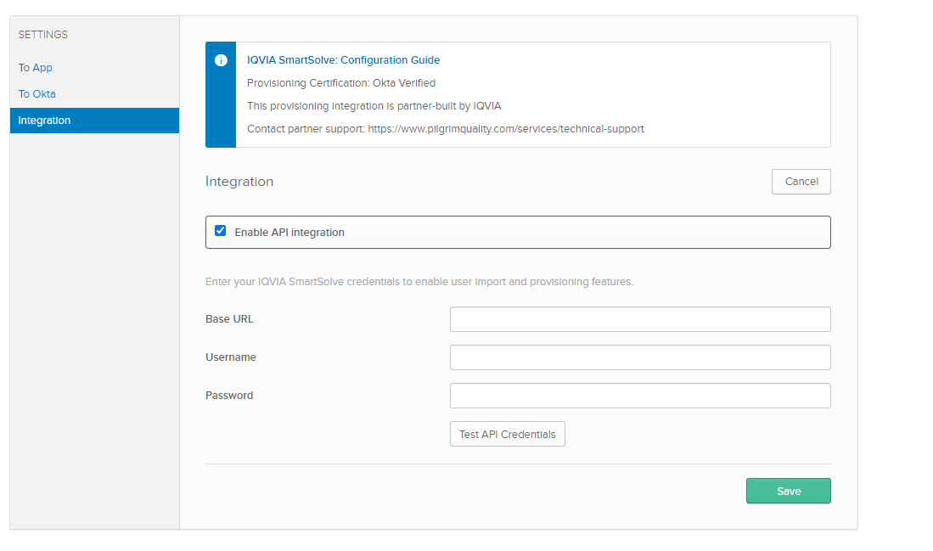
- Click on Test API Credentials. Click on Save if passes
- Click on To App under Settings
- Click Edit and select Enable for the following options.
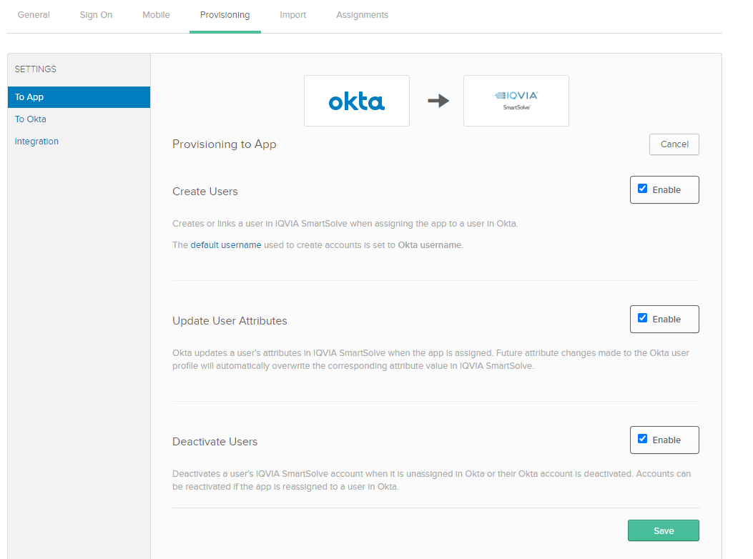

Configure Mapping
The table below describes the attributes used to provision in SmartSolve.
Attributes | SmartSolve Fields | Notes | Required in SmartSolve? | Default Value set in SmartSolve
Actor Code | Actor Code | This attribute is used to uniquely identify the user in SmartSolve. The value should not contain any special characters. This value is also used as Id in Okta and should only apply on create | Yes
Username | Logon User | The value should not contain any special characters. By default, only user login email prefix is set. | Yes
Name
Given name | First Name |  | Yes
Family name | Last Name |  | Yes
Middle Initial | Middle Initial | Set Initials from the middle name. The value should be less than 10 characters | No
Emails
Primary email | E-mail Address | Only primary email address will be used in SmartSolve. The domain in the email should match the domain of the tenant set in SmartSolve | Yes
Primary email type |  | SmartSolve sets Primary email as primary and of type work
Phone Numbers – Only one number for each of the following phone number type is supported in SmartSolve.
Primary phone | Work Telephone |  | No
Primary phone type |  | Set Primary phone type to work.  SmartSolve sets phone number of type work as primary.
Mobile Phone | Cell Telephone |  | No
Mobile Phone Type |  | Set phone type to mobile for Mobile Phone
Home Phone | Home Telephone |  | No
Home Phone Type |  | Set phone type to home for Home Phone
Fax Phone | Work Fax No |  | No
Fax Phone Type |  | Set phone type to fax for Fax Phone
Home Fax Phone | Home Fax No |  | No
Home Fax Phone Type |  | Set phone type to homeFax for Home Fax Phone
Addresses - Only one primary address of type work will be used in SmartSolve. Address is not required but all properties in address must be available
Street address | Street |  | No
Locality | City |  | No
Region | State |  | No
Postal Code | Zip Code |  | No
Country code | Country |  | No
Address type |  | Set address type to work for this address
Locale | Preferred Locale |  | Yes | us-en
Time zone | Preferred TimeZone | SmartSolve supports windows timezone name. Please refer https://docs.microsoft.com/en-us/windows-hardware/manufacture/desktop/default-time-zones | Yes | Record will be created based on the time zone information in Server
Title | Title | Users Job Title | Yes
Organization | Organization | Assigned Organization needs to be in the SmartSolve application | Yes | GLOBAL
Department | Department | Assigned Department needs to be in the SmartSolve application | Yes | DEFAULT
Site | Site | Assigned Site needs to be in the SmartSolve application | No
Manager value | Manager | Username of the Manager | Yes | SMARTADMIN
Domain | Domain | Domain where the user can be authenticated | Yes | Server name

Troubleshooting
Actor Code Changed in SmartSolve
The value from Actor Code is used as unique identifier in Okta. This value should not be changed in SmartSolve. If the Actor Code has changed in the SmartSolve for the user. The assigned user in Okta will not be able to get pushed for an update. An error with message “No user returned for user [UserName]” will be returned by Okta. Unassign user from the application, update Actor Code in user profile and reassign to re-sync.
Status of the user shows active in the SmartSolve after the user was deactivated in OKTA
This is working as intended. Deactivating a user in Okta will disable log in for the user in SmartSolve but the Status of the user will remain Active.

